**Nama : Bayu Prasetya Adji Sugiyarto**

**NIM : A11.2019.11688**

**Pertemuan : 3**

**Kelompok : A11.4304**

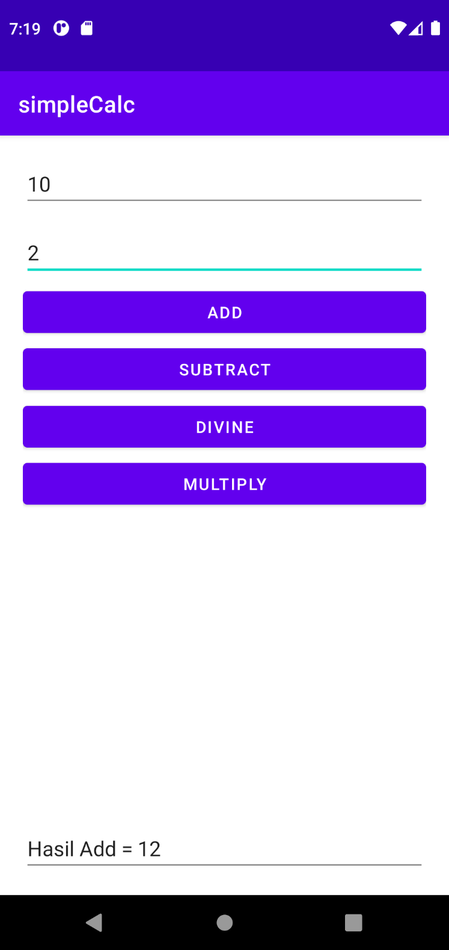**Simple Calculator**

**Mainactivity.java**

package com.example.simplecalc;  
  
import androidx.appcompat.app.AppCompatActivity;  
  
import android.os.Bundle;  
import android.view.View;  
import android.widget.EditText;  
  
public class MainActivity extends AppCompatActivity {  
  
 private EditText txt1;  
 private EditText txt2;  
 private EditText txt3;  
  
 @Override  
 protected void onCreate(Bundle savedInstanceState) {  
 super.onCreate(savedInstanceState);  
 setContentView(R.layout.*activity_main*);  
  
 txt1 = (EditText) findViewById(R.id.*number1*);  
 txt2 = (EditText) findViewById(R.id.*number2*);  
 txt3 = (EditText) findViewById(R.id.*number3*);  
 }  
  
 public void Add(View v){  
  
 int n1 = Integer.*parseInt*(txt1.getText().toString());  
 int n2 = Integer.*parseInt*(txt2.getText().toString());  
 int result = n1+n2;  
  
 txt3.setText("Hasil Add = " + result);  
 }  
  
 public void Substract(View v){  
  
 int n1 = Integer.*parseInt*(txt1.getText().toString());  
 int n2 = Integer.*parseInt*(txt2.getText().toString());  
 int result = n1-n2;  
  
 txt3.setText("Hasil Substract= " + result);  
 }  
  
 public void Multiply(View v){  
  
 int n1 = Integer.*parseInt*(txt1.getText().toString());  
 int n2 = Integer.*parseInt*(txt2.getText().toString());  
 int result = n1*n2;  
  
 txt3.setText("Hasil Multiply= " + result);  
 }  
  
 public void Divine(View v){  
 int n1 = Integer.*parseInt*(txt1.getText().toString());  
 int n2 = Integer.*parseInt*(txt2.getText().toString());  
 int result = n1/n2;  
  
 txt3.setText("Hasil Divine= " + result);  
 }  
}

**activities_main.xml**

*<?*xml version="1.0" encoding="utf-8"*?>*<RelativeLayout xmlns:android="http://schemas.android.com/apk/res/android"  
 xmlns:app="http://schemas.android.com/apk/res-auto"  
 xmlns:tools="http://schemas.android.com/tools"  
 android:layout_width="match_parent"  
 android:layout_height="match_parent"  
 android:layout_marginHorizontal="20dp"  
 tools:context=".MainActivity">  
  
 <EditText  
 android:id="@+id/number1"  
 android:layout_width="match_parent"  
 android:layout_height="wrap_content"  
 android:layout_marginTop="20dp"  
 android:inputType="number" />  
 <EditText  
 android:id="@+id/number2"  
 android:layout_width="match_parent"  
 android:layout_height="wrap_content"  
 android:layout_marginTop="80dp"  
 android:inputType="number" />  
 <Button  
 android:layout_width="match_parent"  
 android:layout_height="wrap_content"  
 android:layout_marginTop="130dp"  
 android:text="ADD"  
 android:onClick="Add"/>  
 <Button  
 android:layout_width="match_parent"  
 android:layout_height="wrap_content"  
 android:layout_marginTop="230dp"  
 android:text="DIVINE"  
 android:onClick="Divine"/>  
 <Button  
 android:layout_width="match_parent"  
 android:layout_height="wrap_content"  
 android:layout_marginTop="180dp"  
 android:text="SUBTRACT"  
 android:onClick="Substract"/>  
 <Button  
 android:layout_width="match_parent"  
 android:layout_height="wrap_content"  
 android:layout_marginTop="280dp"  
 android:text="MULTIPLY"  
 android:onClick="Multiply"/>  
 <EditText  
 android:id="@+id/number3"  
 android:layout_width="match_parent"  
 android:layout_height="wrap_content"  
 android:layout_marginTop="600dp"  
 android:inputType="number" />  
  
  
</RelativeLayout>

**Droid cafe**

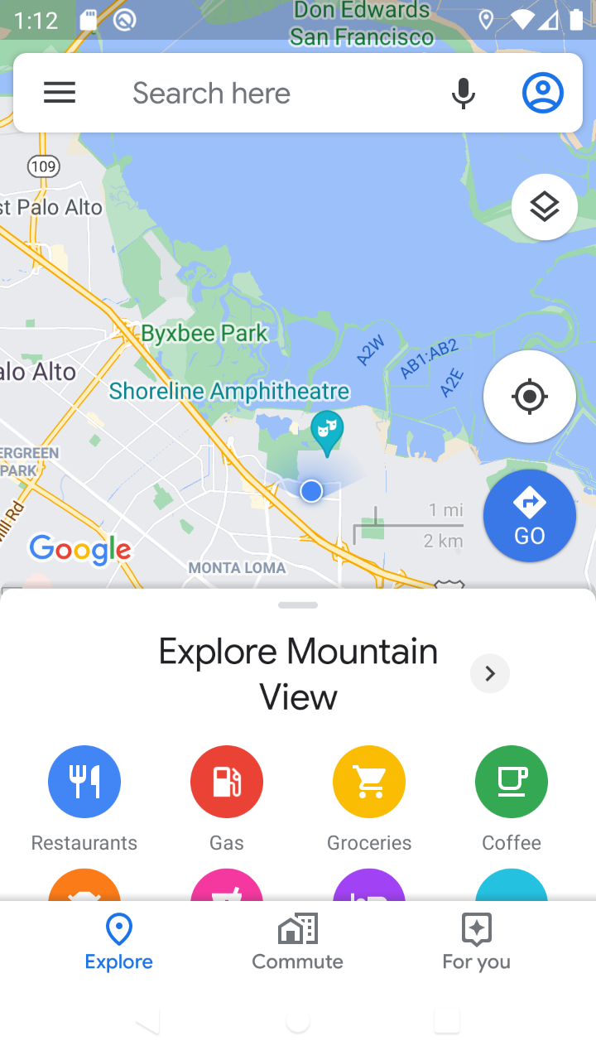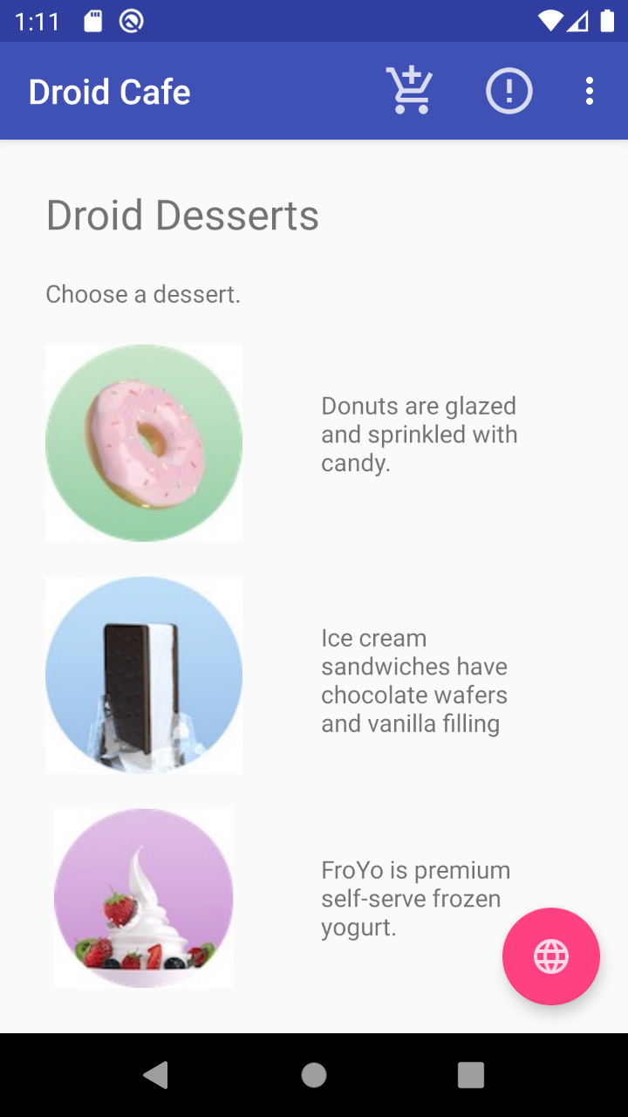

**MainActity.java**

**package** com.example.android.droidcafe;

**import** android.content.Intent;

**import** android.net.Uri;

**import** android.os.Bundle;

**import** android.support.design.widget.FloatingActionButton;

**import** android.support.v7.app.AppCompatActivity;

**import** android.support.v7.widget.Toolbar;

**import** android.view.Menu; **import** android.view.MenuItem; **import** android.view.View; **import** android.widget.Toast;

**public class** MainActivity **extends** AppCompatActivity { @Override

**protected void** onCreate(Bundle savedInstanceState) {

**super**.onCreate(savedInstanceState); setContentView(R.layout.***activity_main***);

Toolbar toolbar = (Toolbar) findViewById(R.id.***toolbar***); setSupportActionBar(toolbar);

FloatingActionButton fab = (FloatingActionButton) findViewById(R.id.***fab***); fab.setOnClickListener(**new** View.OnClickListener() {

@Override

**public void** onClick(View view) { displayMap();

}

});

}

@Override

**public boolean** onCreateOptionsMenu(Menu menu) { getMenuInflater().inflate(R.menu.***menu_main***, menu); **return true**;

}

@Override

**public boolean** onOptionsItemSelected(MenuItem item) {

**switch** (item.getItemId()) {

**case** R.id.***action_order***: displayToast(getString(R.string.***action_order_message***)); **return true**;

**case** R.id.***action_status***: displayToast(getString(R.string.***action_status_message***)); **return true**;

**case** R.id.***action_favorites***: displayToast(getString(R.string.***action_favorites_message***)); **return true**;

**case** R.id.***action_contact***: displayToast(getString(R.string.***action_contact_message***)); **return true**;

**default**:

}

**return super**.onOptionsItemSelected(item);

}

**public void** showDonutOrder(View view) { showFoodOrder(getString(R.string.***donut_order_message***));

}

**public void** showIceCreamOrder(View view) { showFoodOrder(getString(R.string.***ice_cream_order_message***));

}

**public void** showFroyoOrder(View view) { showFoodOrder(getString(R.string.***froyo_order_message***));

}

**public void** showFoodOrder(String message) { displayToast(message);

Intent intent = **new** Intent(**this**, OrderActivity.**class**); startActivity(intent);

}

**public void** displayToast(String message) {

Toast.*makeText*(getApplicationContext(), message, Toast.***LENGTH_SHORT***).show();

}

**public void** displayMap() { Intent intent = **new** Intent();

intent.setAction(Intent.***ACTION_VIEW***);*.*

String data = getString(R.string.***google_mtv_coord_zoom12***); intent.setData(Uri.*parse*(data));

**if** (intent.resolveActivity(getPackageManager()) != **null**) { startActivity(intent);

}

}

}

**Activity_Main.xml**

*<?***xml version="1.0" encoding="utf-8"***?>*

<**android.support.design.widget.CoordinatorLayout xmlns:android=**[**"http://schemas.android.com/apk/res/android"**](http://schemas.android.com/apk/res/android)

**xmlns:app=**[**"http://schemas.android.com/apk/res**](http://schemas.android.com/apk/res-auto)**-**[**auto"**](http://schemas.android.com/apk/res-auto) **xmlns:tools=**[**"http://schemas.android.com/tools"**](http://schemas.android.com/tools) **android:layout_width="match_parent" android:layout_height="match_parent" android:fitsSystemWindows="true" tools:context="com.example.android.droidcafe.MainActivity"**>

<**android.support.design.widget.AppBarLayout android:layout_width="match_parent" android:layout_height="wrap_content" android:theme="@style/AppTheme.AppBarOverlay"**>

<**android.support.v7.widget.Toolbar android:id="@+id/toolbar" android:layout_width="match_parent" android:layout_height="?attr/actionBarSize" android:background="?attr/colorPrimary" app:popupTheme="@style/AppTheme.PopupOverlay"** />

</**android.support.design.widget.AppBarLayout**>

<**include layout="@layout/content_main"** />

<**android.support.design.widget.FloatingActionButton android:id="@+id/fab" android:layout_width="wrap_content" android:layout_height="wrap_content" android:layout_gravity="bottom|end" android:layout_margin="@dimen/fab_margin" app:srcCompat="@drawable/ic_map"** />

</**android.support.design.widget.CoordinatorLayout**>

**Perhitungan**

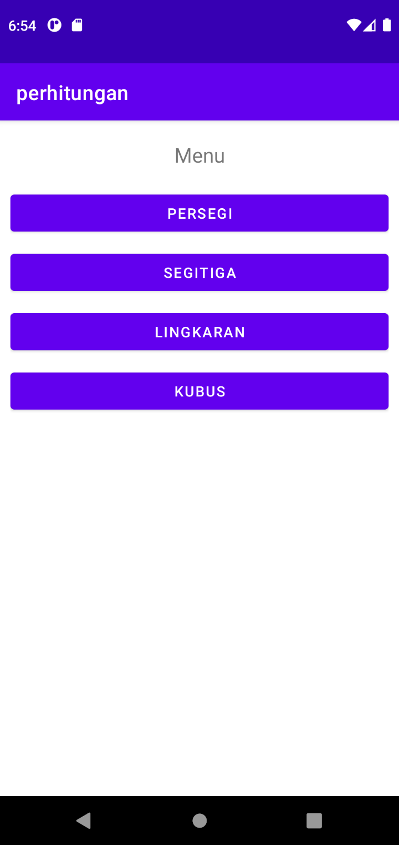

**Mainactivity.java**

package com.example.perhitungan;  
  
import androidx.appcompat.app.AppCompatActivity;  
  
import android.content.Intent;  
import android.os.Bundle;  
import android.view.View;  
  
public class MainActivity extends AppCompatActivity {  
  
 @Override  
 protected void onCreate(Bundle savedInstanceState) {  
 super.onCreate(savedInstanceState);  
 setContentView(R.layout.*activity_main*);  
 }  
  
 public void openPersegi(View view){  
 Intent i = new Intent(this, Persegi.class);  
 startActivity(i);  
 }  
  
 public void openKubus(View view){  
 Intent i = new Intent(this, kubus.class);  
 startActivity(i);  
 }  
  
 public void openSegitiga(View view){  
 Intent i = new Intent(this, segitiga.class);  
 startActivity(i);  
 }  
  
 public void openLingkaran(View view){  
 Intent i = new Intent(this, lingkaran.class);  
 startActivity(i);  
 }  
  
}

**activity_main.xml**

*<?*xml version="1.0" encoding="utf-8"*?>*<LinearLayout xmlns:android="http://schemas.android.com/apk/res/android"  
 xmlns:app="http://schemas.android.com/apk/res-auto"  
 xmlns:tools="http://schemas.android.com/tools"  
 android:layout_width="match_parent"  
 android:layout_height="match_parent"  
 android:layout_marginTop="20dp"  
 android:layout_marginBottom="20dp"  
 android:layout_marginHorizontal="10dp"  
 android:orientation="vertical"  
 tools:context=".MainActivity">  
  
 <TextView  
 android:id="@+id/menu"  
 android:layout_width="match_parent"  
 android:layout_height="wrap_content"  
 android:text="Menu"  
 android:textAlignment="center"  
 android:textSize="20dp" />  
 <Button  
 android:id="@+id/persegi"  
 android:layout_width="match_parent"  
 android:layout_height="wrap_content"  
 android:text="Persegi"  
 android:layout_marginTop="20dp"  
 android:onClick="openPersegi"/>  
 <Button  
 android:id="@+id/segitiga"  
 android:layout_width="match_parent"  
 android:layout_height="wrap_content"  
 android:text="Segitiga"  
 android:layout_marginTop="10dp"  
 android:onClick="openSegitiga"/>  
 <Button  
 android:id="@+id/lingkaran"  
 android:layout_width="match_parent"  
 android:layout_height="wrap_content"  
 android:text="Lingkaran"  
 android:layout_marginTop="10dp"  
 android:onClick="openLingkaran"/>  
 <Button  
 android:id="@+id/kubus"  
 android:layout_width="match_parent"  
 android:layout_height="wrap_content"  
 android:text="Kubus"  
 android:layout_marginTop="10dp"  
 android:onClick="openKubus"/>  
  
</LinearLayout>

**Persegi**

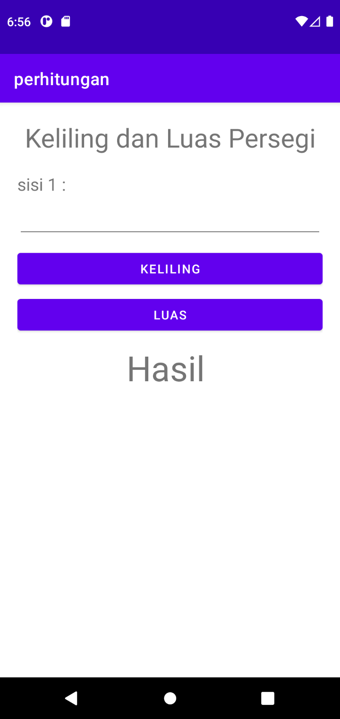

**Persegi.java**

package com.example.perhitungan;  
  
import androidx.appcompat.app.AppCompatActivity;  
  
import android.os.Bundle;  
import android.util.Log;  
import android.view.View;  
import android.widget.EditText;  
import android.widget.TextView;  
  
public class Persegi extends AppCompatActivity {  
  
 private EditText sisiEdit;  
 private TextView Hasil;  
 private float nilai,hsl;  
  
 @Override  
 protected void onCreate(Bundle savedInstanceState) {  
 super.onCreate(savedInstanceState);  
 setContentView(R.layout.*activity_persegi*);  
  
 sisiEdit = findViewById(R.id.*sisi*);  
 Hasil = findViewById(R.id.*hasil*);  
 }  
  
 public void keliling(View view){  
 try{  
 nilai = Float.*parseFloat*(sisiEdit.getText().toString());  
 hsl = nilai * 4 ;  
 Hasil.setText(Float.*toString*(hsl));  
 }catch (NumberFormatException e){  
 Log.*d*("Error", "Error Format" + e);  
 }  
 }  
  
 public void luas(View view) {  
 try {  
 nilai = Float.*parseFloat*(sisiEdit.getText().toString());  
 hsl = nilai * nilai;  
 Hasil.setText(Float.*toString*(hsl));  
 } catch (NumberFormatException e) {  
 Log.*d*("Error", "Error Format " + e);  
 }  
 }  
  
  
}

**activity_persegi.xml**

*<?*xml version="1.0" encoding="utf-8"*?>*<LinearLayout xmlns:android="http://schemas.android.com/apk/res/android"  
 xmlns:app="http://schemas.android.com/apk/res-auto"  
 xmlns:tools="http://schemas.android.com/tools"  
 android:layout_width="match_parent"  
 android:layout_height="match_parent"  
 android:orientation="vertical"  
 android:layout_marginVertical="20dp"  
 android:layout_marginHorizontal="20dp"  
 tools:context=".Persegi">  
  
 <TextView  
 android:layout_width="match_parent"  
 android:layout_height="wrap_content"  
 android:text="Keliling dan Luas Persegi"  
 android:textSize="30dp"  
 android:textAlignment="center"/>  
  
 <TextView  
 android:layout_width="match_parent"  
 android:layout_height="wrap_content"  
 android:layout_marginTop="20dp"  
 android:text="sisi 1 : "  
 android:textSize="20dp" />  
  
 <EditText  
 android:id="@+id/sisi"  
 android:inputType="number"  
 android:layout_width="match_parent"  
 android:layout_height="wrap_content"  
 android:layout_marginTop="5dp"  
 />  
  
 <Button  
 android:id="@+id/btnkeliling"  
 android:layout_width="match_parent"  
 android:layout_height="wrap_content"  
 android:layout_marginTop="10dp"  
 android:text="Keliling"  
 android:onClick="keliling"/>  
  
 <Button  
 android:id="@+id/btnluas"  
 android:layout_width="match_parent"  
 android:layout_height="wrap_content"  
 android:layout_marginTop="5dp"  
 android:text="Luas"  
 android:onClick="luas"/>  
  
 <TextView  
 android:id="@+id/hasil"  
 android:layout_width="match_parent"  
 android:layout_height="wrap_content"  
 android:layout_marginTop="10dp"  
 android:text="Hasil "  
 android:textAlignment="center"  
 android:textSize="40dp" />  
  
</LinearLayout>

**Segitiga**

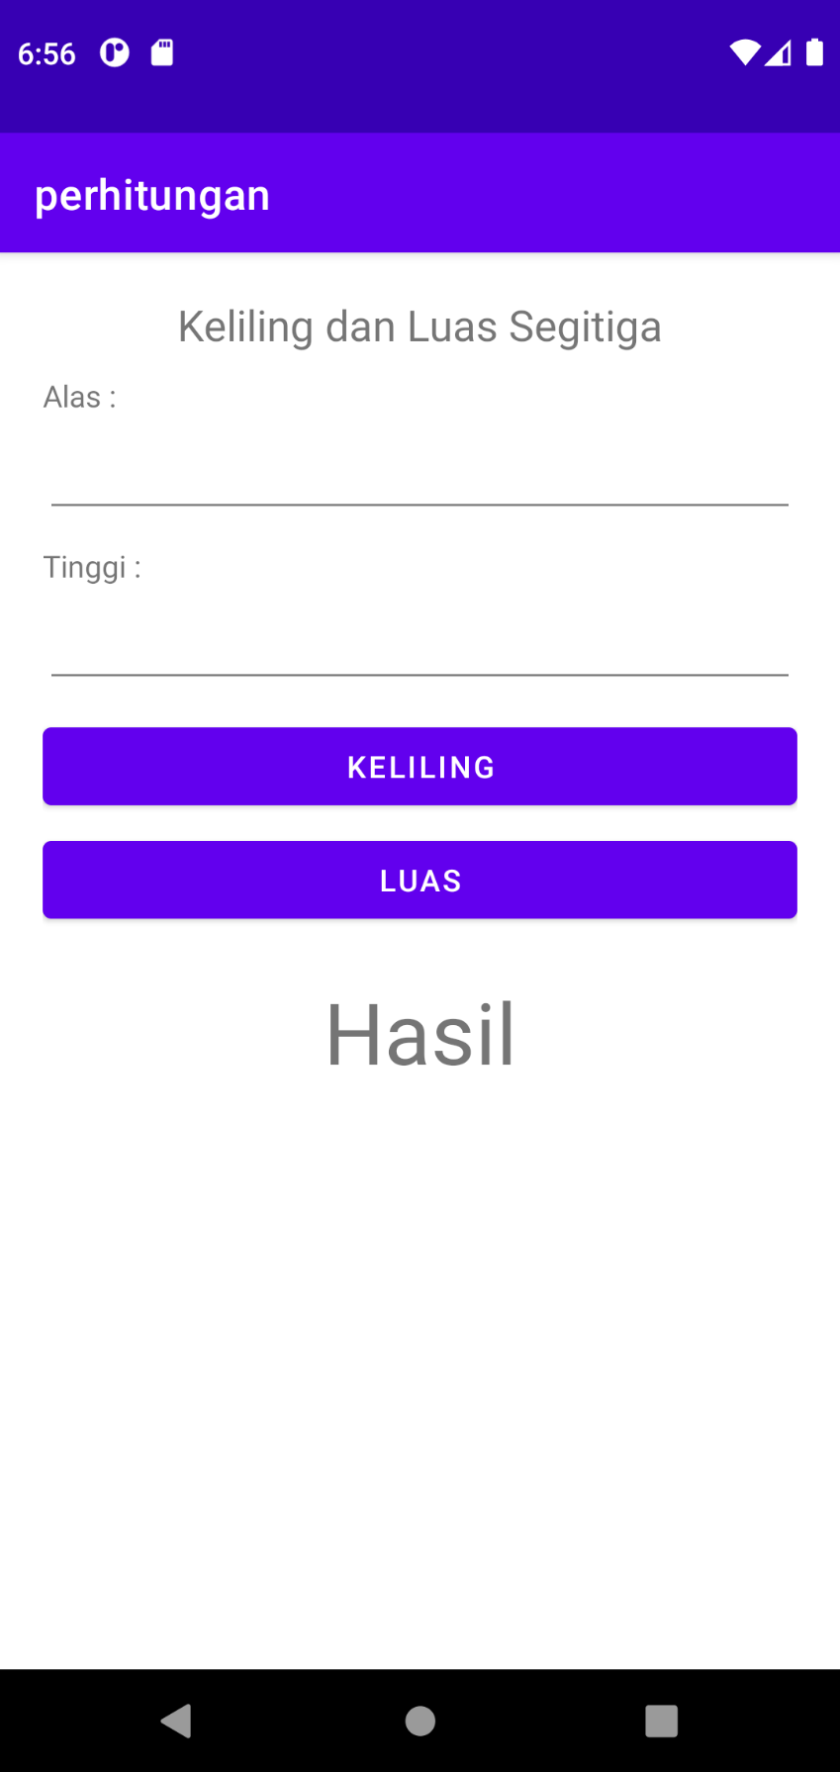

**Segitiga.java**

package com.example.perhitungan;  
  
import androidx.appcompat.app.AppCompatActivity;  
  
import android.os.Bundle;  
import android.util.Log;  
import android.view.View;  
import android.widget.EditText;  
import android.widget.TextView;  
  
public class segitiga extends AppCompatActivity {  
  
 private EditText nilai1,nilai2;  
 private TextView hasil;  
 private float n1, n2, hsl, pangkat, miring;  
  
 @Override  
 protected void onCreate(Bundle savedInstanceState) {  
 super.onCreate(savedInstanceState);  
 setContentView(R.layout.*activity_segitiga*);  
  
 nilai1 = findViewById(R.id.*alas*);  
 nilai2 = findViewById(R.id.*tinggi*);  
 hasil = findViewById(R.id.*hasilsegitiga*);  
 }  
  
 public void kelilingsgt(View view){  
 try {  
 n1 = Float.*parseFloat*(nilai1.getText().toString());  
 n2 = Float.*parseFloat*(nilai2.getText().toString());  
 pangkat = 2;  
 miring = (float) Math.*sqrt*(Math.*pow*(n1, pangkat)+Math.*pow*(n2, pangkat));  
  
 hsl = n1 + n2 + miring;  
 hasil.setText(Float.*toString*(hsl));  
 }catch (NumberFormatException e){  
 Log.*d*("Error", "Error Format" + e);  
 }  
 }  
  
 public void luassgt(View view){  
 try {  
 n1 = Float.*parseFloat*(nilai1.getText().toString());  
 n2 = Float.*parseFloat*(nilai2.getText().toString());  
  
 hsl = (float) (0.5 * n1 *n2);  
 hasil.setText(Float.*toString*(hsl));  
 }catch (NumberFormatException e){  
 Log.*d*("Error", "Error Format" + e);  
 }  
 }  
}

**activity_segitiga.xml**

*<?*xml version="1.0" encoding="utf-8"*?>*<LinearLayout xmlns:android="http://schemas.android.com/apk/res/android"  
 xmlns:app="http://schemas.android.com/apk/res-auto"  
 xmlns:tools="http://schemas.android.com/tools"  
 android:layout_width="match_parent"  
 android:layout_height="match_parent"  
 android:layout_marginHorizontal="20dp"  
 android:layout_marginVertical="20dp"  
 android:orientation="vertical"  
 tools:context=".segitiga">  
  
 <TextView  
 android:layout_width="match_parent"  
 android:layout_height="wrap_content"  
 android:text="Keliling dan Luas Segitiga"  
 android:textAlignment="center"  
 android:textSize="20dp"/>  
  
 <TextView  
 android:layout_width="match_parent"  
 android:layout_height="wrap_content"  
 android:text="Alas : "  
 android:layout_marginTop="10dp"/>  
  
 <EditText  
 android:id="@+id/alas"  
 android:layout_width="match_parent"  
 android:layout_height="wrap_content"  
 android:layout_marginTop="5dp"/>  
  
 <TextView  
 android:layout_width="match_parent"  
 android:layout_height="wrap_content"  
 android:text="Tinggi : "  
 android:layout_marginTop="10dp"/>  
  
 <EditText  
 android:id="@+id/tinggi"  
 android:layout_width="match_parent"  
 android:layout_height="wrap_content"  
 android:layout_marginTop="5dp"/>  
  
 <Button  
 android:id="@+id/btnsegitiga"  
 android:layout_width="match_parent"  
 android:layout_height="wrap_content"  
 android:layout_marginTop="10dp"  
 android:text="Keliling"  
 android:onClick="kelilingsgt"/>  
  
 <Button  
 android:id="@+id/btnluassegitiga"  
 android:layout_width="match_parent"  
 android:layout_height="wrap_content"  
 android:text="Luas"  
 android:layout_marginTop="5dp"  
 android:onClick="luassgt"/>  
  
 <TextView  
 android:id="@+id/hasilsegitiga"  
 android:layout_width="match_parent"  
 android:layout_height="wrap_content"  
 android:text="Hasil"  
 android:textSize="40dp"  
 android:textAlignment="center"  
 android:layout_marginTop="20dp"/>  
</LinearLayout>

**Lingkaran**

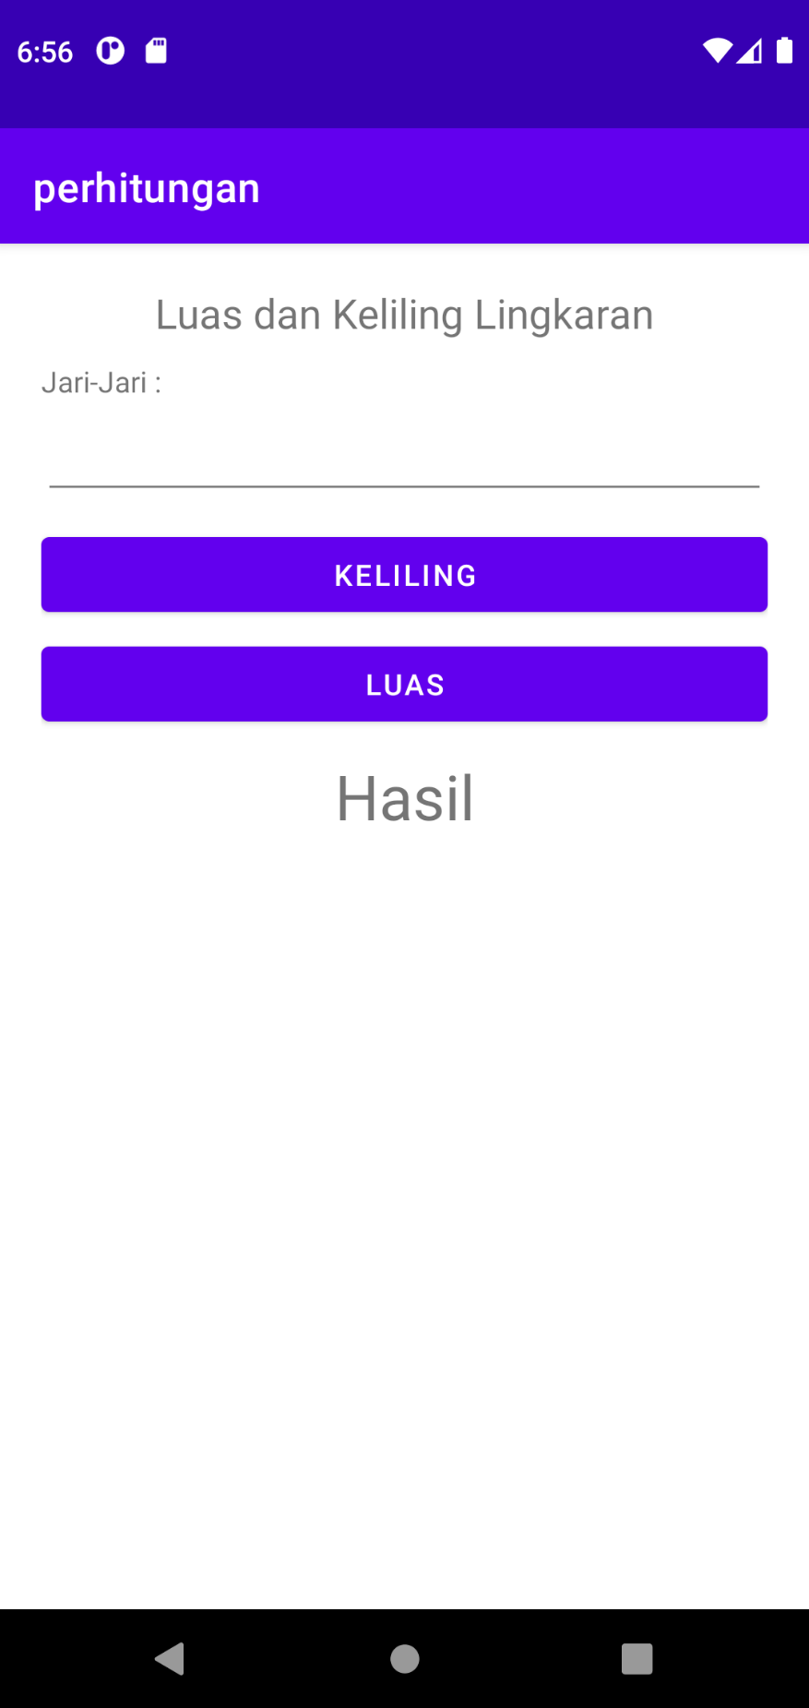

**Lingkaran.java**

package com.example.perhitungan;  
  
import androidx.appcompat.app.AppCompatActivity;  
  
import android.os.Bundle;  
import android.util.Log;  
import android.view.View;  
import android.widget.EditText;  
import android.widget.TextView;  
  
public class lingkaran extends AppCompatActivity {  
  
 private EditText nilai;  
 private TextView hasil;  
 private float n1 , hsl, phi, pangkat;  
  
 @Override  
 protected void onCreate(Bundle savedInstanceState) {  
 super.onCreate(savedInstanceState);  
 setContentView(R.layout.*activity_lingkaran*);  
  
 nilai = findViewById(R.id.*Jari*);  
 hasil = findViewById(R.id.*hasillingkaran*);  
 }  
  
 public void kelilingLing(View view){  
 try {  
 n1 = Float.*parseFloat*(nilai.getText().toString());  
 phi = (float) 3.14;  
  
 hsl = 2 * phi * n1;  
 hasil.setText(Float.*toString*(hsl));  
 }catch (NumberFormatException e){  
 Log.*d*("Error", "Error Format" + e);  
 }  
 }  
  
 public void luasLing(View view){  
 try {  
 n1 = Float.*parseFloat*(nilai.getText().toString());  
 pangkat = 2;  
 hsl = (float) (phi * Math.*pow*(n1 , pangkat));  
 hasil.setText(Float.*toString*(hsl));  
 }catch (NumberFormatException e){  
 Log.*d*("Error", "Error Format" + e);  
 }  
 }  
  
}

**activity_lingkaran.xml**

*<?*xml version="1.0" encoding="utf-8"*?>*<LinearLayout xmlns:android="http://schemas.android.com/apk/res/android"  
 xmlns:app="http://schemas.android.com/apk/res-auto"  
 xmlns:tools="http://schemas.android.com/tools"  
 android:layout_width="match_parent"  
 android:layout_height="match_parent"  
 android:orientation="vertical"  
 android:layout_marginVertical="20dp"  
 android:layout_marginHorizontal="20dp"  
 tools:context=".lingkaran">  
  
 <TextView  
 android:layout_width="match_parent"  
 android:layout_height="wrap_content"  
 android:text="Luas dan Keliling Lingkaran"  
 android:textAlignment="center"  
 android:textSize="20dp"/>  
  
 <TextView  
 android:layout_width="match_parent"  
 android:layout_height="wrap_content"  
 android:text="Jari-Jari : "  
 android:layout_marginTop="10dp"/>  
  
 <EditText  
 android:id="@+id/Jari"  
 android:layout_width="match_parent"  
 android:layout_height="wrap_content"  
 android:layout_marginTop="5dp"  
 />  
  
 <Button  
 android:layout_width="match_parent"  
 android:layout_height="wrap_content"  
 android:text="Keliling"  
 android:layout_marginTop="10dp"  
 android:onClick="kelilingLing"/>  
  
 <Button  
 android:layout_width="match_parent"  
 android:layout_height="wrap_content"  
 android:text="Luas"  
 android:layout_marginTop="5dp"  
 android:onClick="luasLing"/>  
  
 <TextView  
 android:id="@+id/hasillingkaran"  
 android:layout_width="match_parent"  
 android:layout_height="wrap_content"  
 android:text="Hasil"  
 android:textSize="30dp"  
 android:textAlignment="center"  
 android:layout_marginTop="10dp" />  
  
</LinearLayout>

**Kubus**

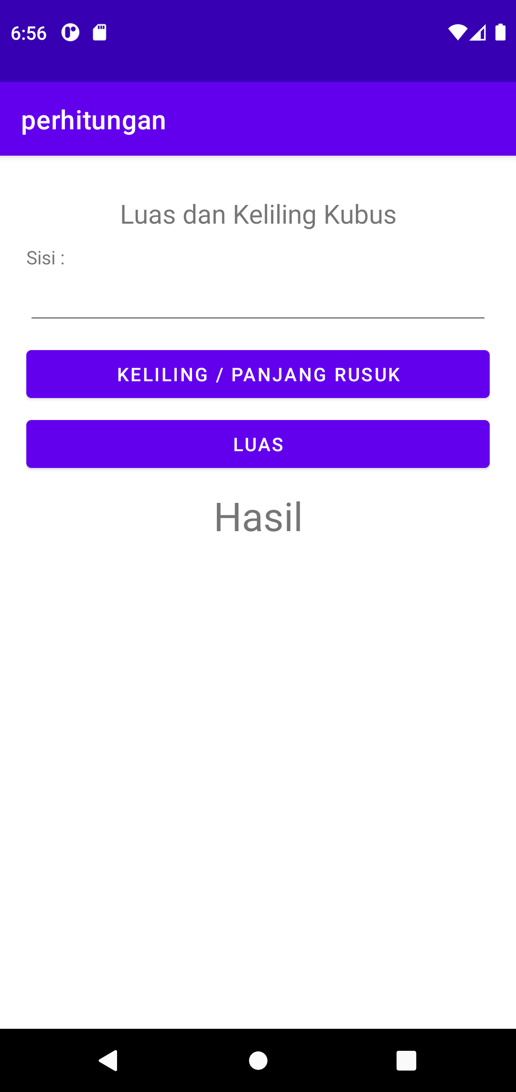

**Kubus.java**

package com.example.perhitungan;  
  
import androidx.appcompat.app.AppCompatActivity;  
  
import android.os.Bundle;  
import android.util.Log;  
import android.view.View;  
import android.widget.EditText;  
import android.widget.TextView;  
  
public class kubus extends AppCompatActivity {  
  
 private EditText nilai;  
 private TextView hasil;  
 private float n1, hsl, pangkat;  
  
 @Override  
 protected void onCreate(Bundle savedInstanceState) {  
 super.onCreate(savedInstanceState);  
 setContentView(R.layout.*activity_kubus*);  
  
 nilai = findViewById(R.id.*sisikbs*);  
 hasil = findViewById(R.id.*hasilkubus*);  
 }  
  
 public void panjangrusuk(View view){  
 try{  
 n1 = Float.*parseFloat*(nilai.getText().toString());  
  
 hsl = (float) (12 * n1);  
 hasil.setText(Float.*toString*(hsl));  
 }catch (NumberFormatException e){  
 Log.*d*("Error", "Error Format" + e);  
 }  
 }  
  
 public void luaskubus(View view){  
 try {  
 n1 = Float.*parseFloat*(nilai.getText().toString());  
 pangkat = 2;  
  
 hsl = (float) (6 * Math.*pow*(n1, pangkat));  
 hasil.setText(Float.*toString*(hsl));  
 }catch (NumberFormatException e){  
 Log.*d*("Error", "Error Format" + e);  
 }  
 }  
}

**activity_kubus.xml**

*<?*xml version="1.0" encoding="utf-8"*?>*<LinearLayout xmlns:android="http://schemas.android.com/apk/res/android"  
 xmlns:app="http://schemas.android.com/apk/res-auto"  
 xmlns:tools="http://schemas.android.com/tools"  
 android:layout_width="match_parent"  
 android:layout_height="match_parent"  
 android:orientation="vertical"  
 android:layout_marginHorizontal="20dp"  
 android:layout_marginVertical="20dp"  
 tools:context=".kubus">  
  
 <TextView  
 android:layout_width="match_parent"  
 android:layout_height="wrap_content"  
 android:text="Luas dan Keliling Kubus"  
 android:layout_marginTop="10dp"  
 android:textSize="20dp"  
 android:textAlignment="center"/>  
  
 <TextView  
 android:layout_width="match_parent"  
 android:layout_height="wrap_content"  
 android:text="Sisi : "  
 android:layout_marginTop="10dp"/>  
  
 <EditText  
 android:id="@+id/sisikbs"  
 android:layout_width="match_parent"  
 android:layout_height="wrap_content"/>  
  
 <Button  
 android:layout_width="match_parent"  
 android:layout_height="wrap_content"  
 android:text="Keliling / Panjang Rusuk"  
 android:layout_marginTop="10dp"  
 android:onClick="panjangrusuk"/>  
  
 <Button  
 android:layout_width="match_parent"  
 android:layout_height="wrap_content"  
 android:text="Luas"  
 android:layout_marginTop="5dp"  
 android:onClick="luaskubus"/>  
  
 <TextView  
 android:id="@+id/hasilkubus"  
 android:layout_width="match_parent"  
 android:layout_height="wrap_content"  
 android:textSize="30dp"  
 android:textAlignment="center"  
 android:text="Hasil"  
 android:layout_marginTop="10dp"/>  
  
</LinearLayout>